**INFOGRAPHIC**

[**https://digitalmarketing2316.blogspot.com/2023/09/infographic-sunday-with-saud.html**](https://digitalmarketing2316.blogspot.com/2023/09/infographic-sunday-with-saud.html)

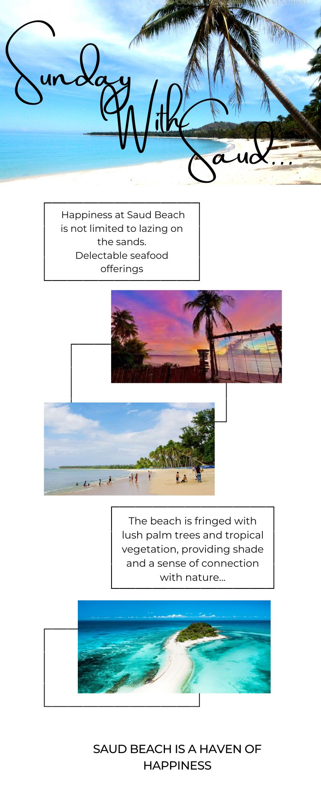

**EMAIL NEWSLETTER**

[**https://digitalmarketing2316.blogspot.com/2023/09/httpheavenwithcandy2316.blogspot.com.html**](https://digitalmarketing2316.blogspot.com/2023/09/httpheavenwithcandy2316.blogspot.com.html)



**BLOG**

[**https://www.blogger.com/blog/posts/4773864123589743132**](https://www.blogger.com/blog/posts/4773864123589743132)

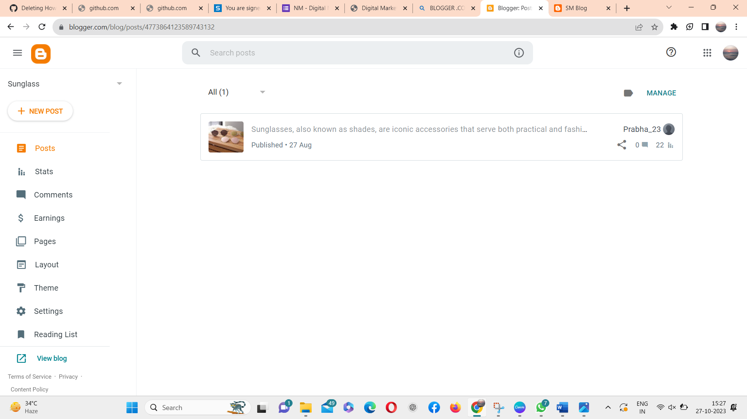

**FACEBOOK**

<https://www.facebook.com/profile.php?id=61552679826772>

